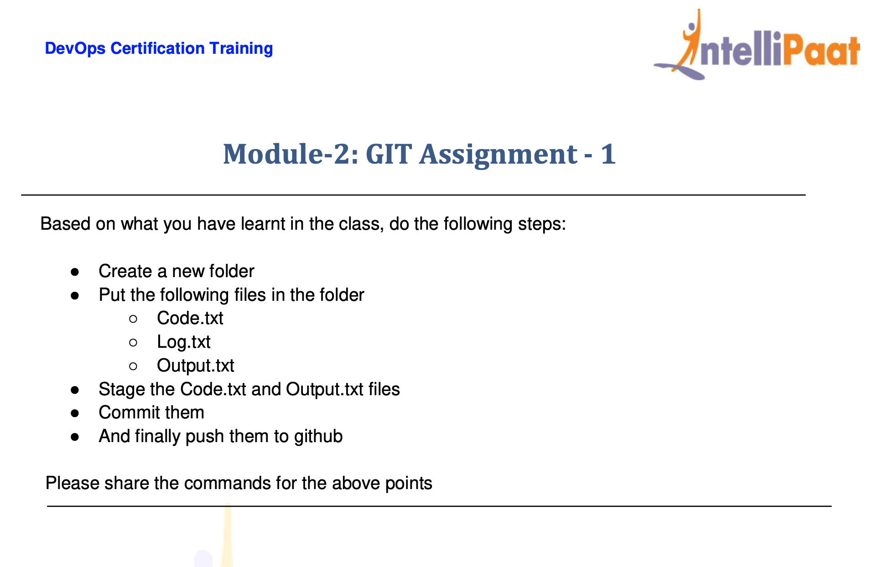

Login to AWS Console and installed the git by below commands.

install Git on - Ubuntu OS

sudo su -

sudo apt-get install software-properties-common

sudo add-apt-repository ppa:git-core/ppa -y

sudo apt-get update

sudo apt-get install git -y

git --version ( if it writes the version then the installation is successful )

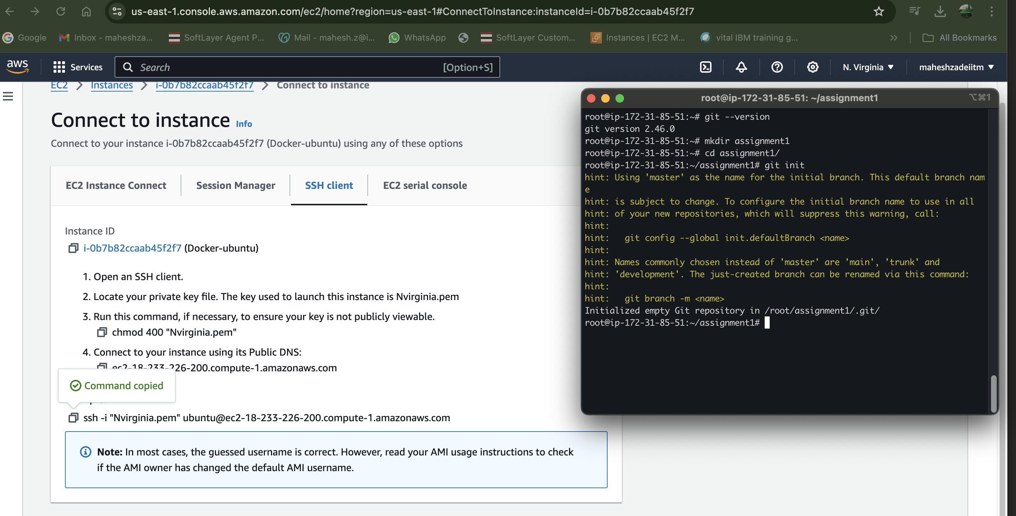

Created the folder Assignment1 and git initialized by the command git init.

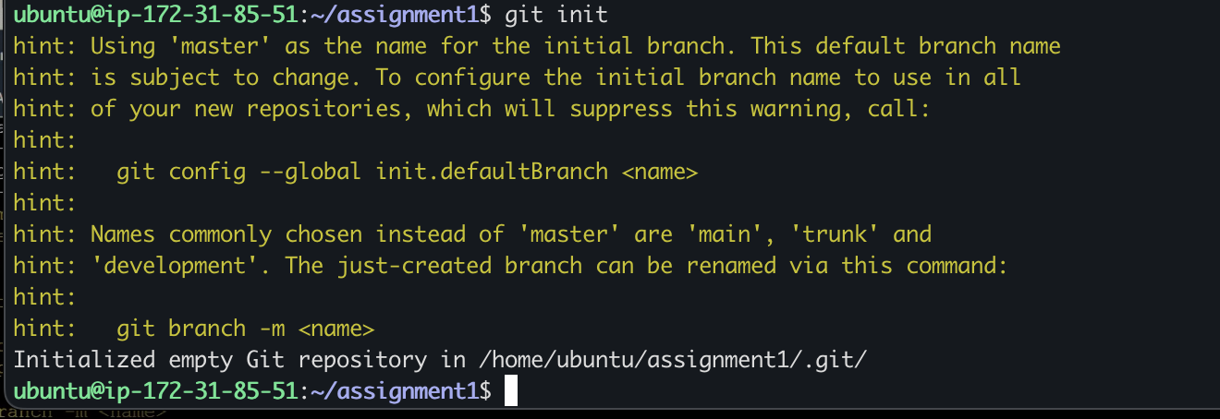

ubuntu@ip-172-31-85-51:~/assignment1$ ls -a

. .. .git

ubuntu@ip-172-31-85-51:~/assignment1$

root@ip-172-31-85-51:~/assignment1# pwd

/root/assignment1

root@ip-172-31-85-51:~/assignment1#

root@ip-172-31-85-51:~/assignment1# git status

On branch master

No commits yet

nothing to commit (create/copy files and use "git add" to track)

Now Create the 3 files

Put the following files in the folder

Code.txt

Log.txt

Output.txt

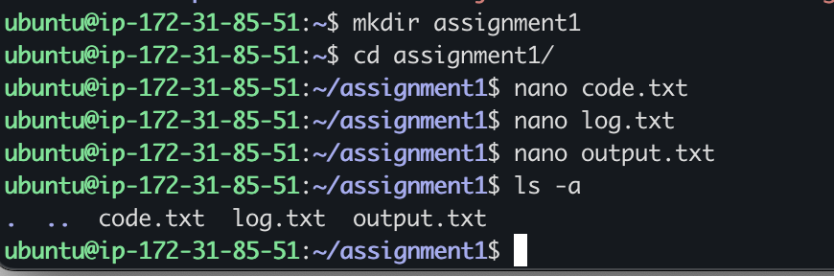

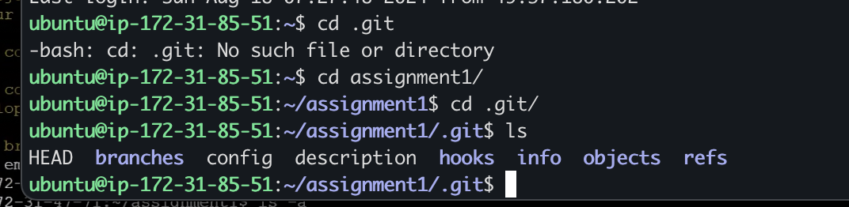

ubuntu@ip-172-31-85-51:~/assignment1/.git$ ls

HEAD branches config description hooks info objects refs

ubuntu@ip-172-31-85-51:~/assignment1/.git$ cd ..

ubuntu@ip-172-31-85-51:~/assignment1$ git branch

ubuntu@ip-172-31-85-51:~/assignment1$

branch is not showing before commit

untracked files

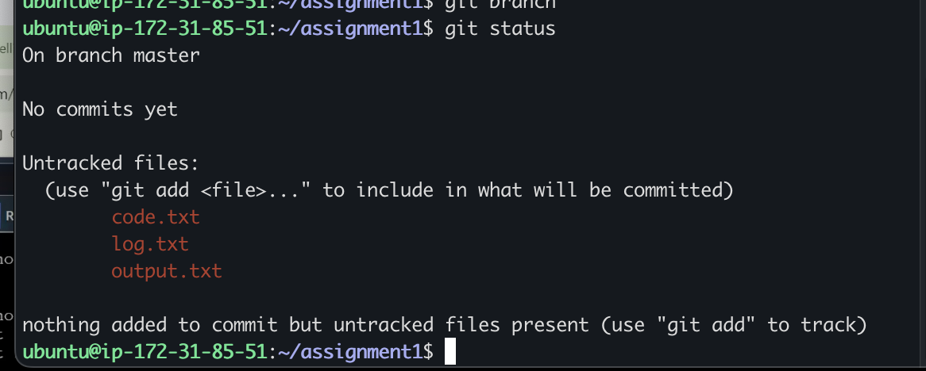

Unless and until your master branch will not show till 1st commit.

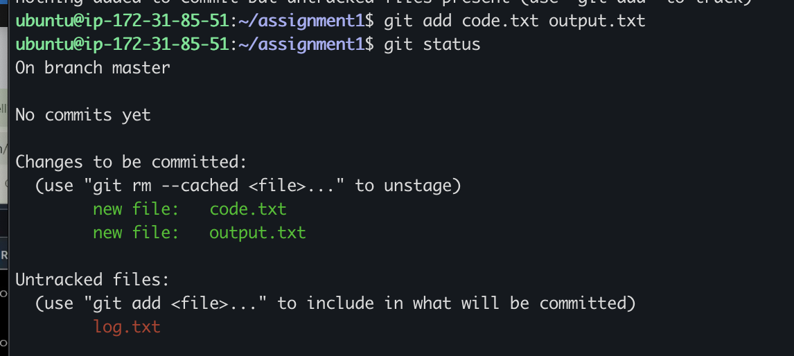

Now do git commit to stage it

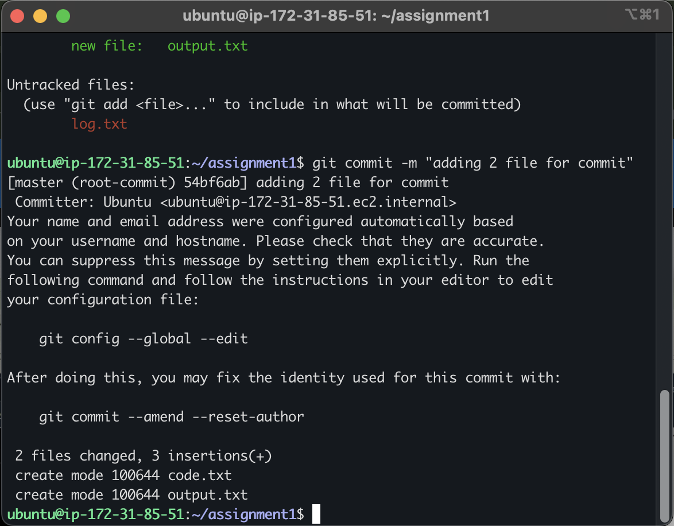

Now login to self github account

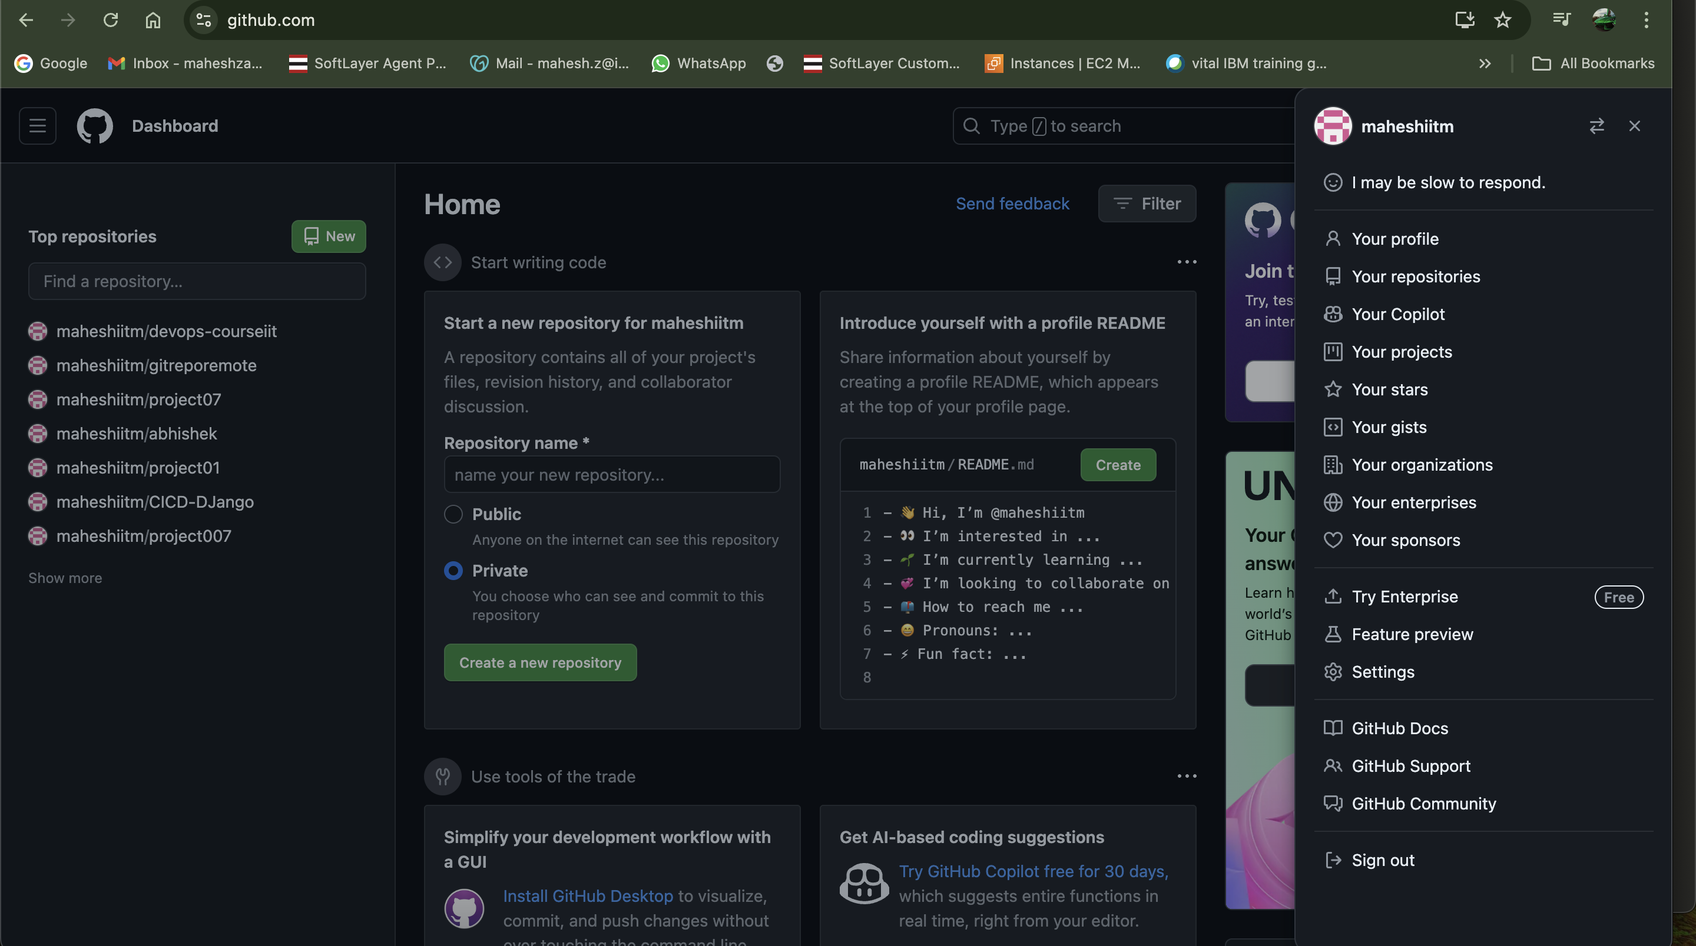

Make the repository as 18thaugassignment1 and make it public

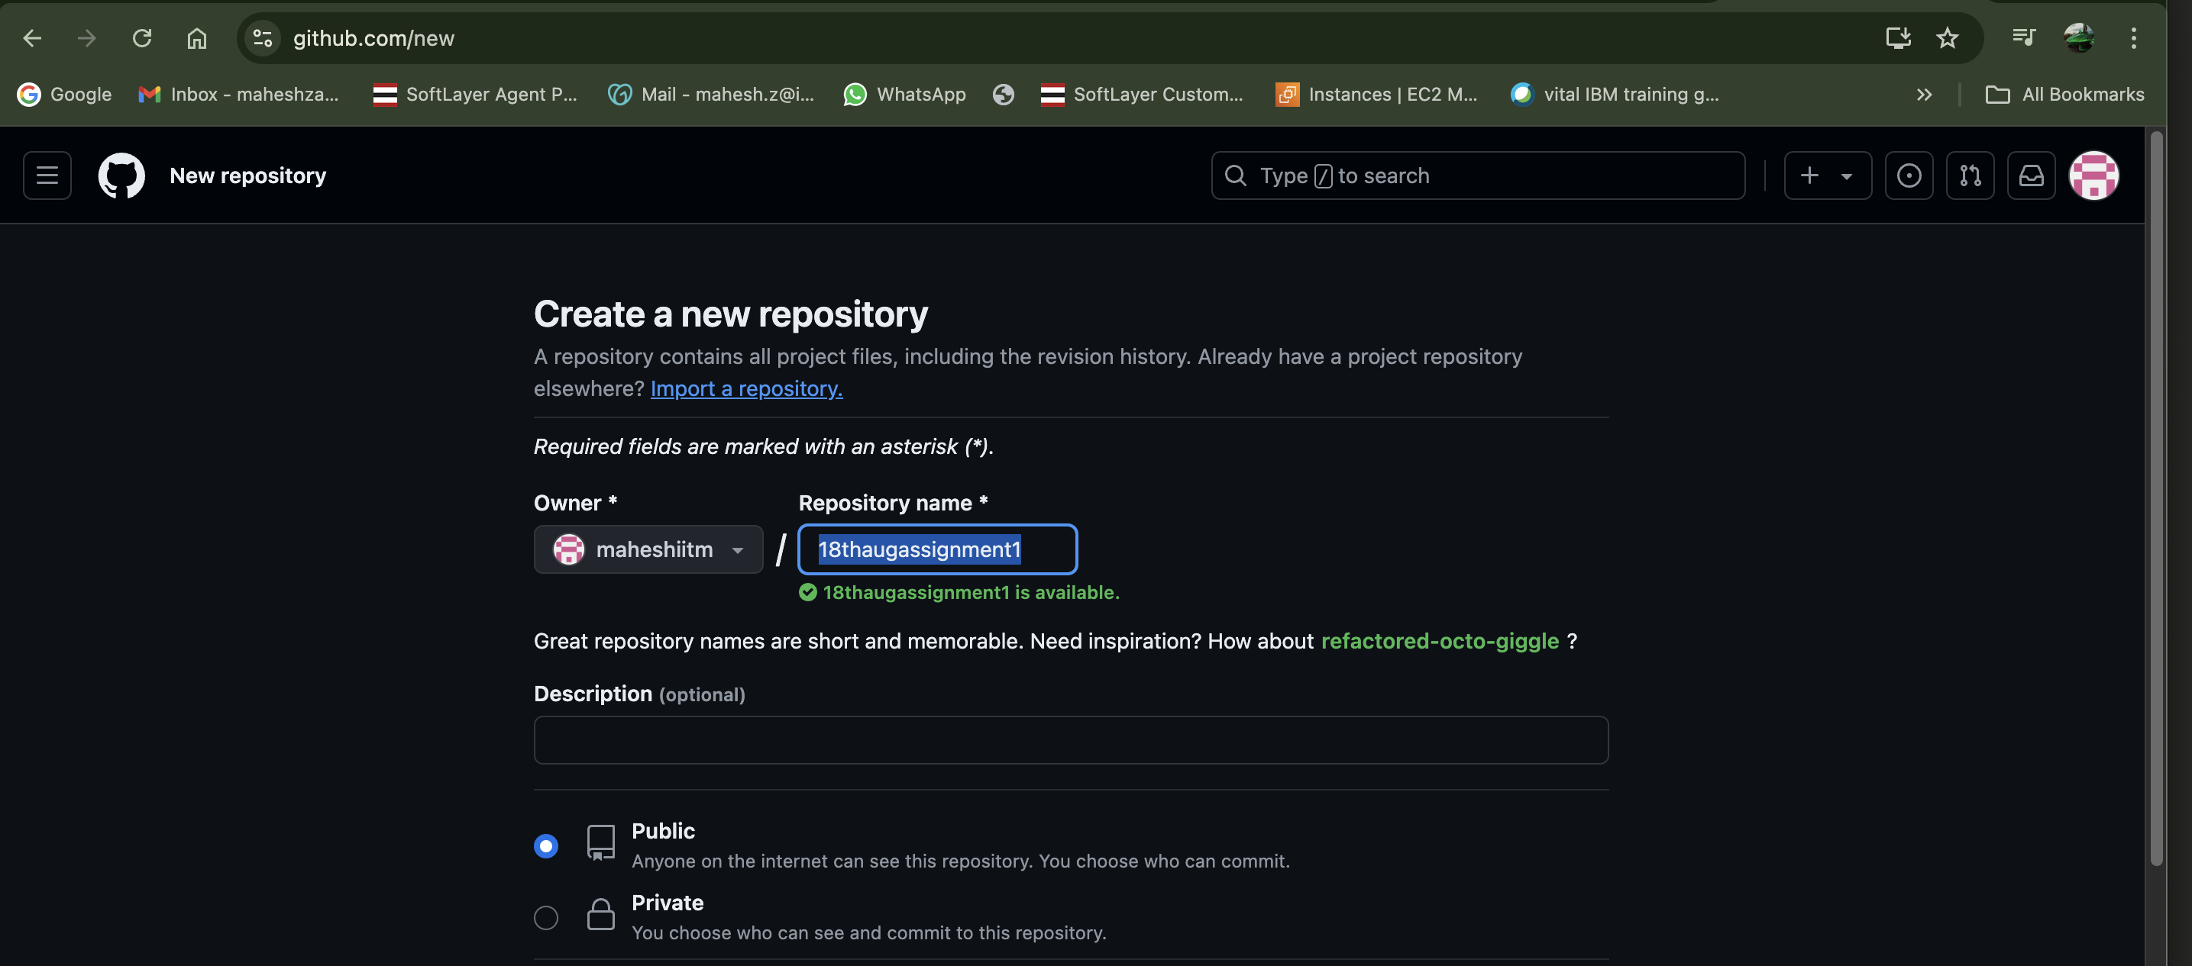

Click on create repository

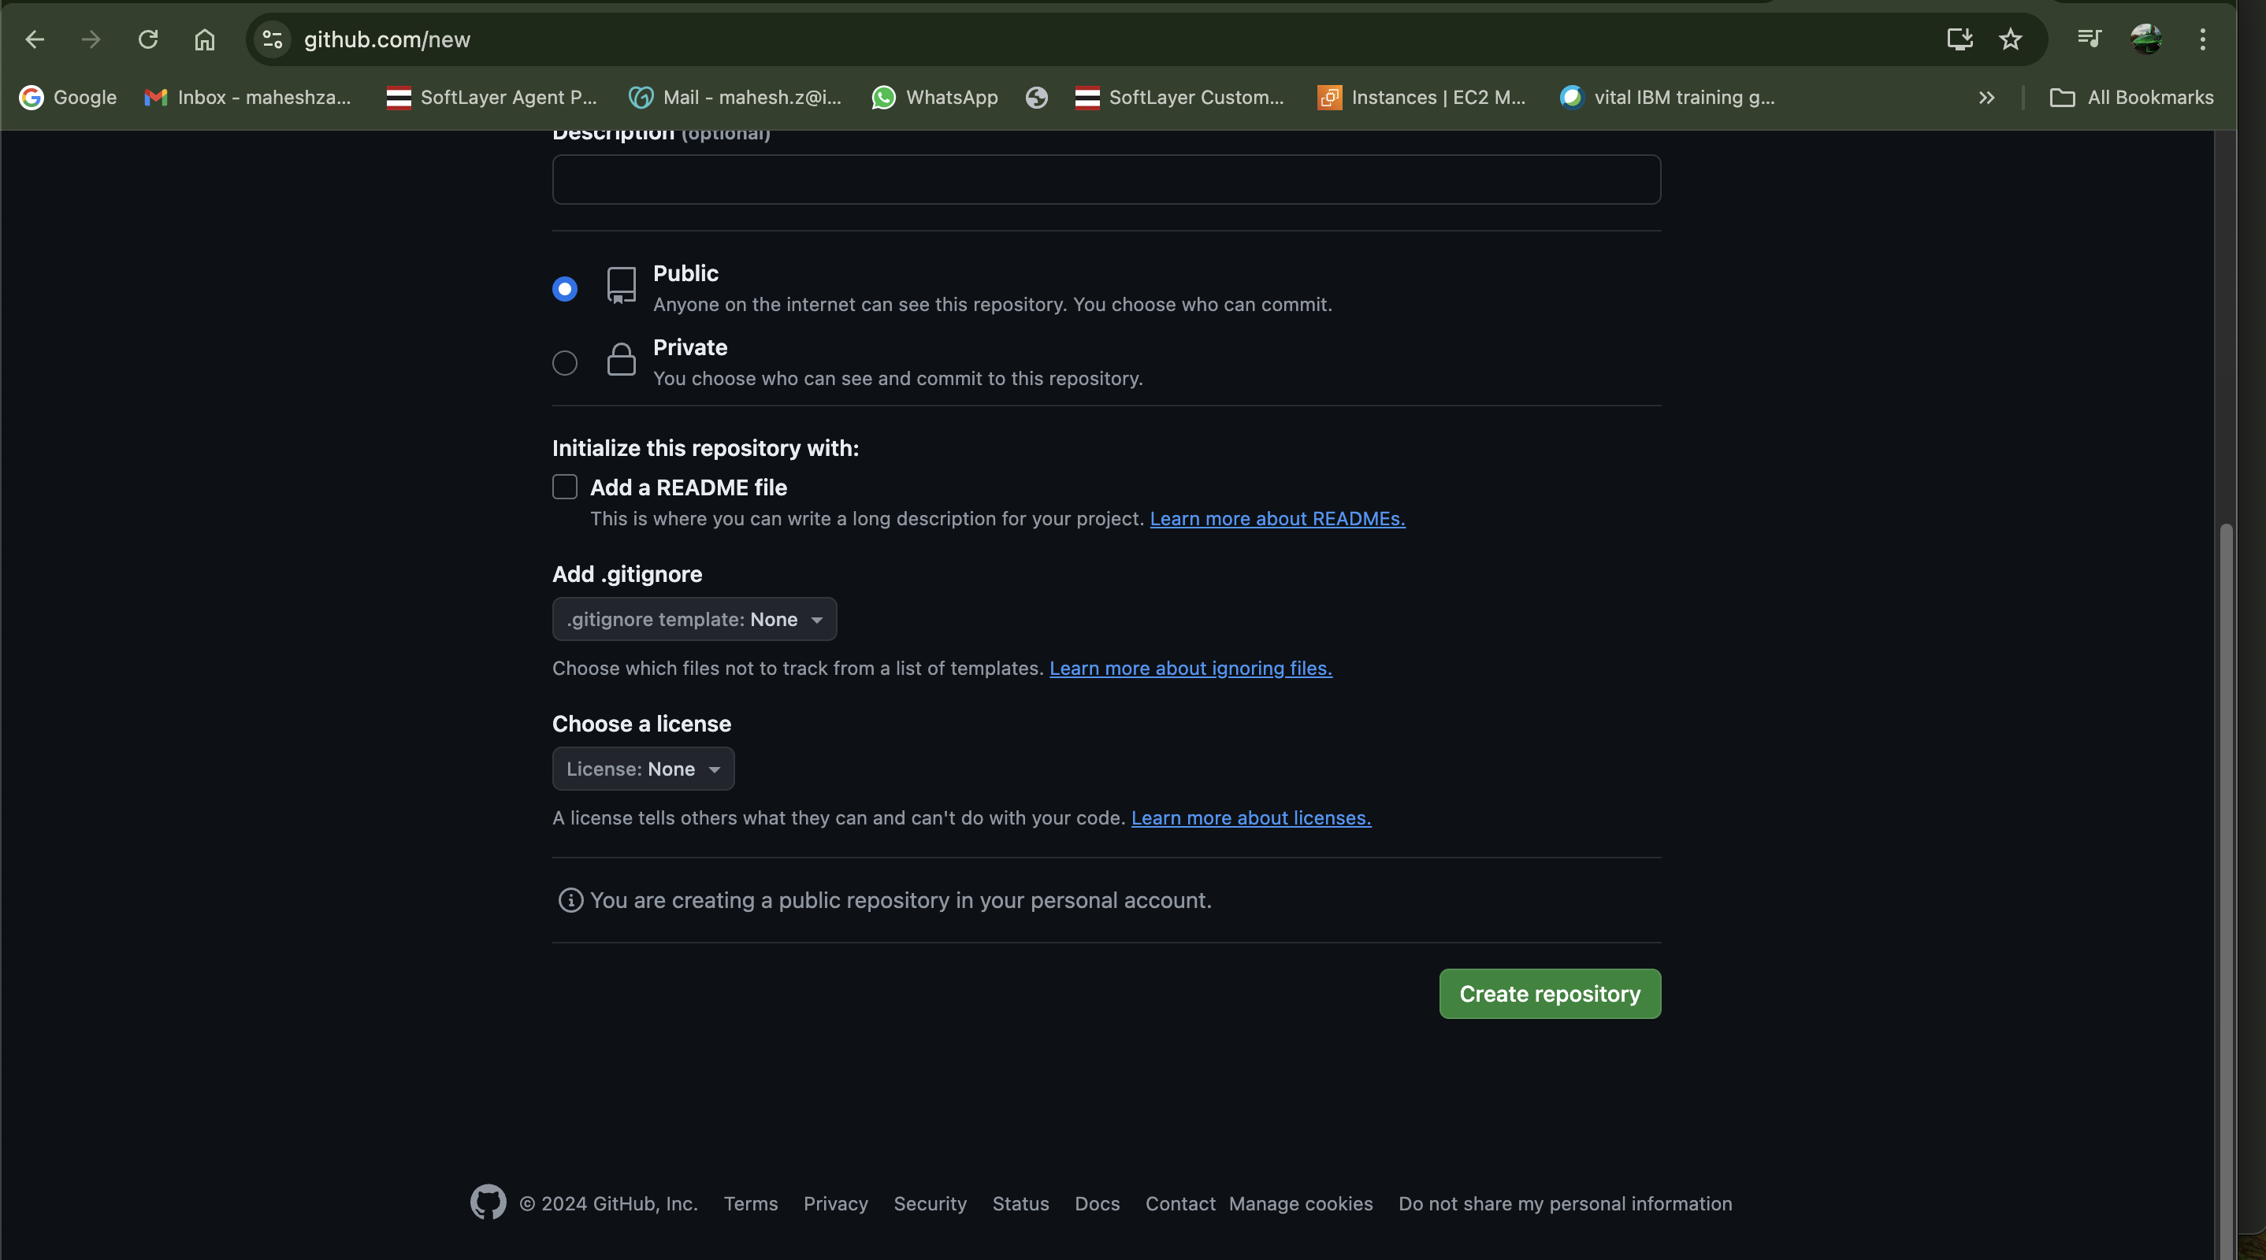

Respository created

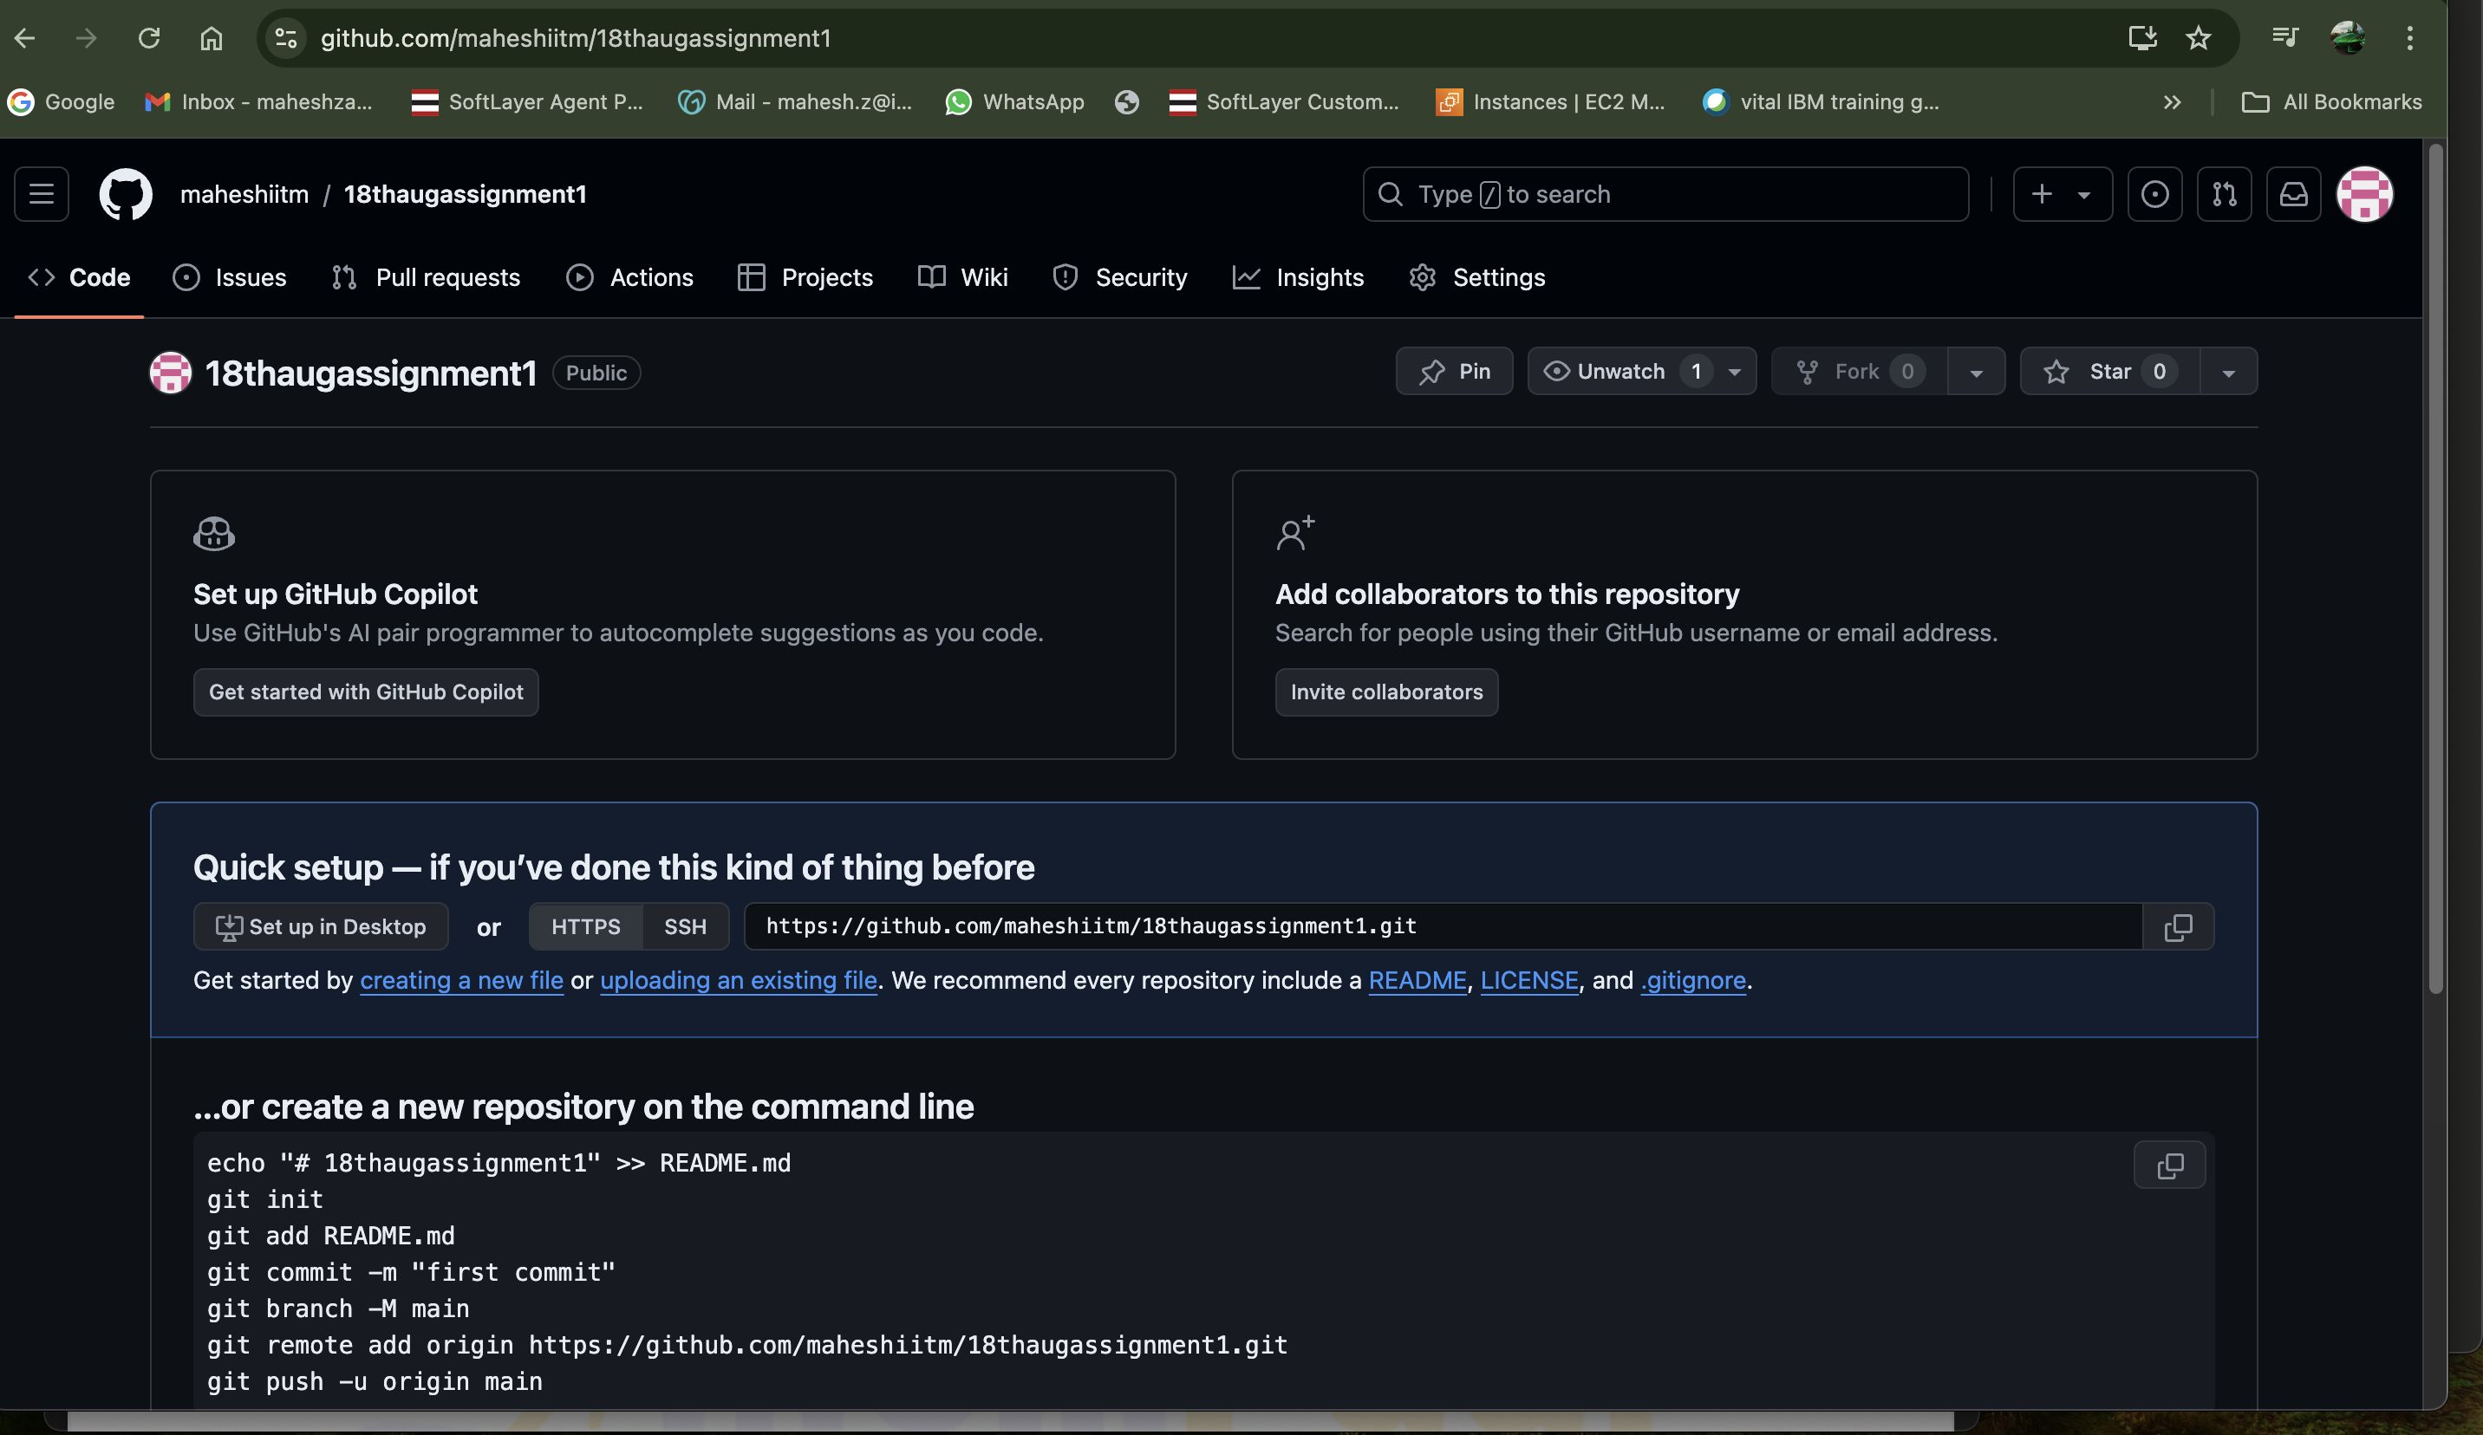

Git branch need to check

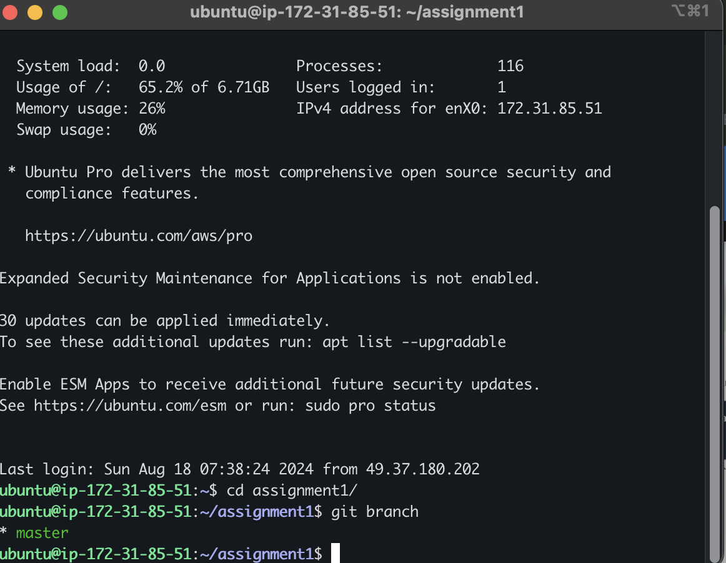

Copy the url from the git hub and push the local repository to git hub

To check the any file in the remore repository check the below command

git remote -v

ubuntu@ip-172-31-85-51:~$ cd assignment1/

ubuntu@ip-172-31-85-51:~/assignment1$ git branch

\* master

ubuntu@ip-172-31-85-51:~/assignment1$ git remote -v

ubuntu@ip-172-31-85-51:~/assignment1$

copy the url from the github repository to the server

<https://github.com/maheshiitm/18thaugassignment1.git>

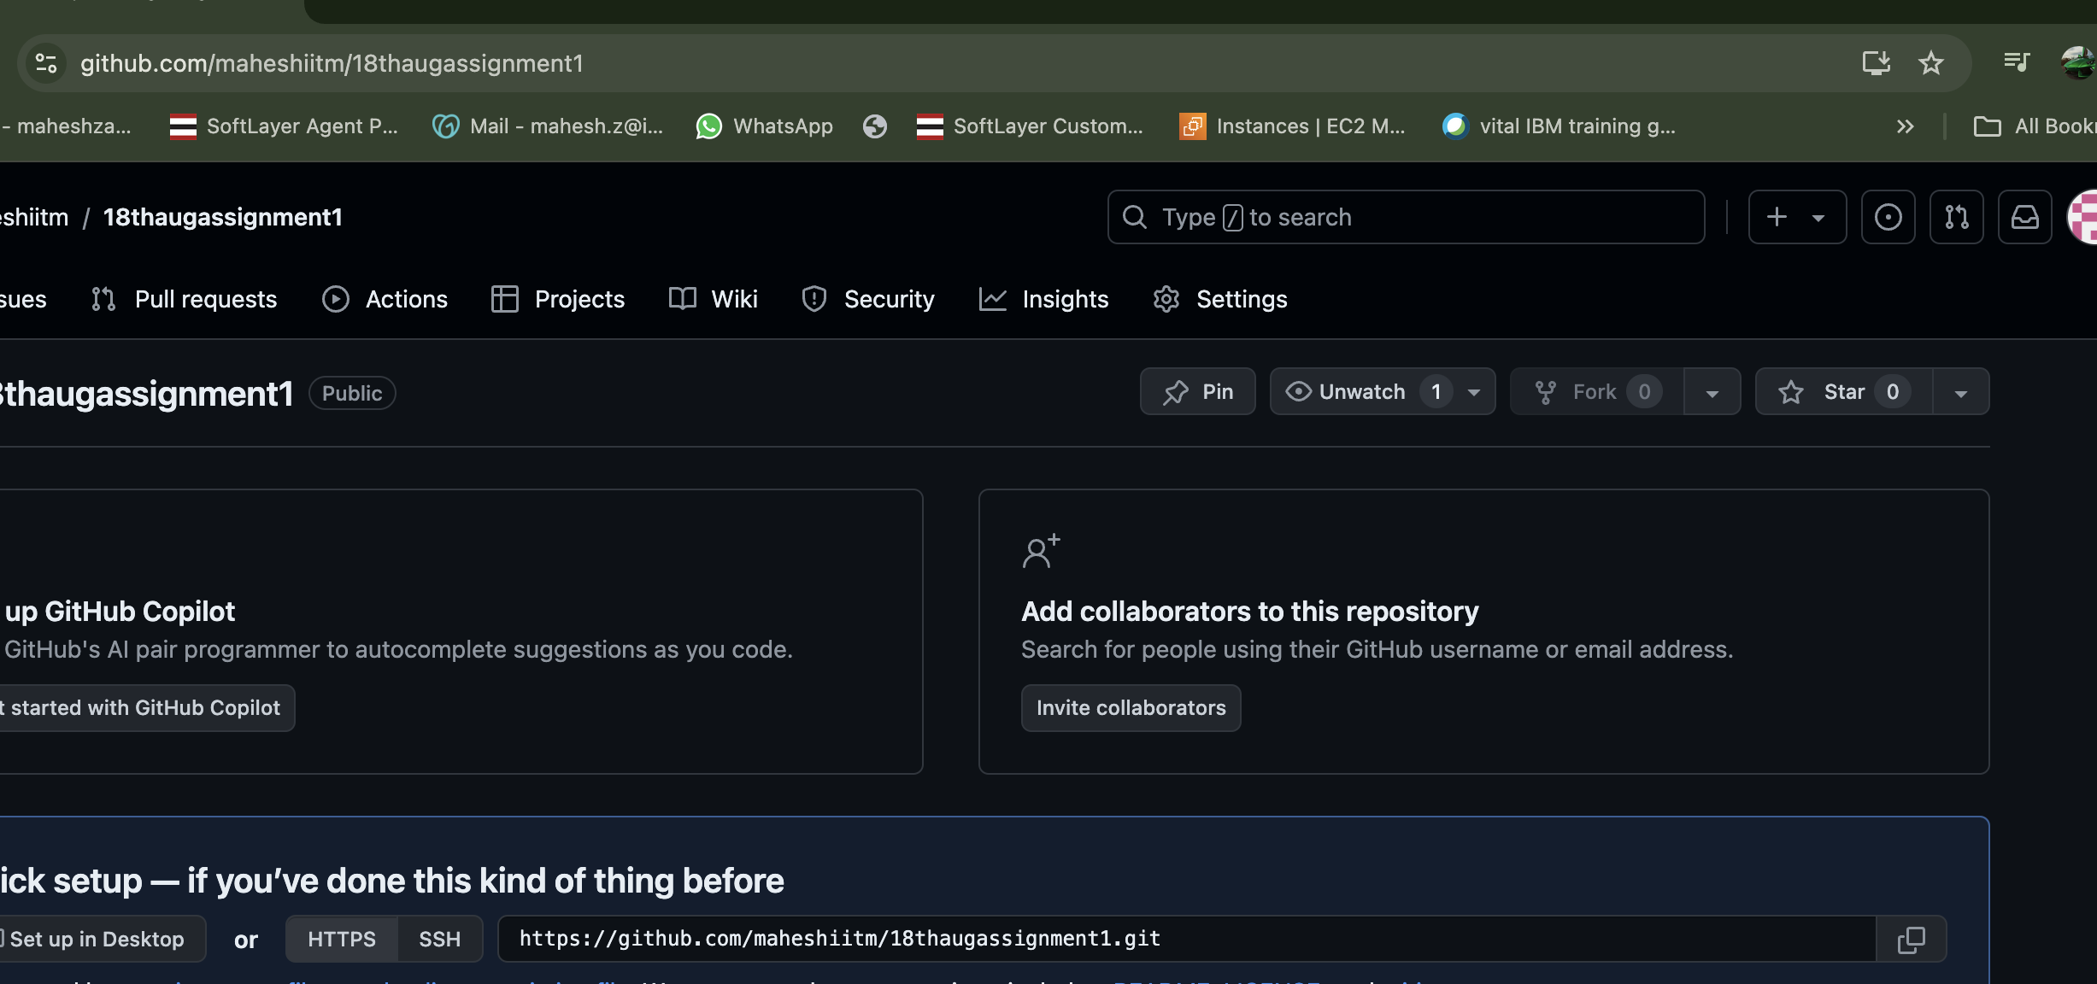

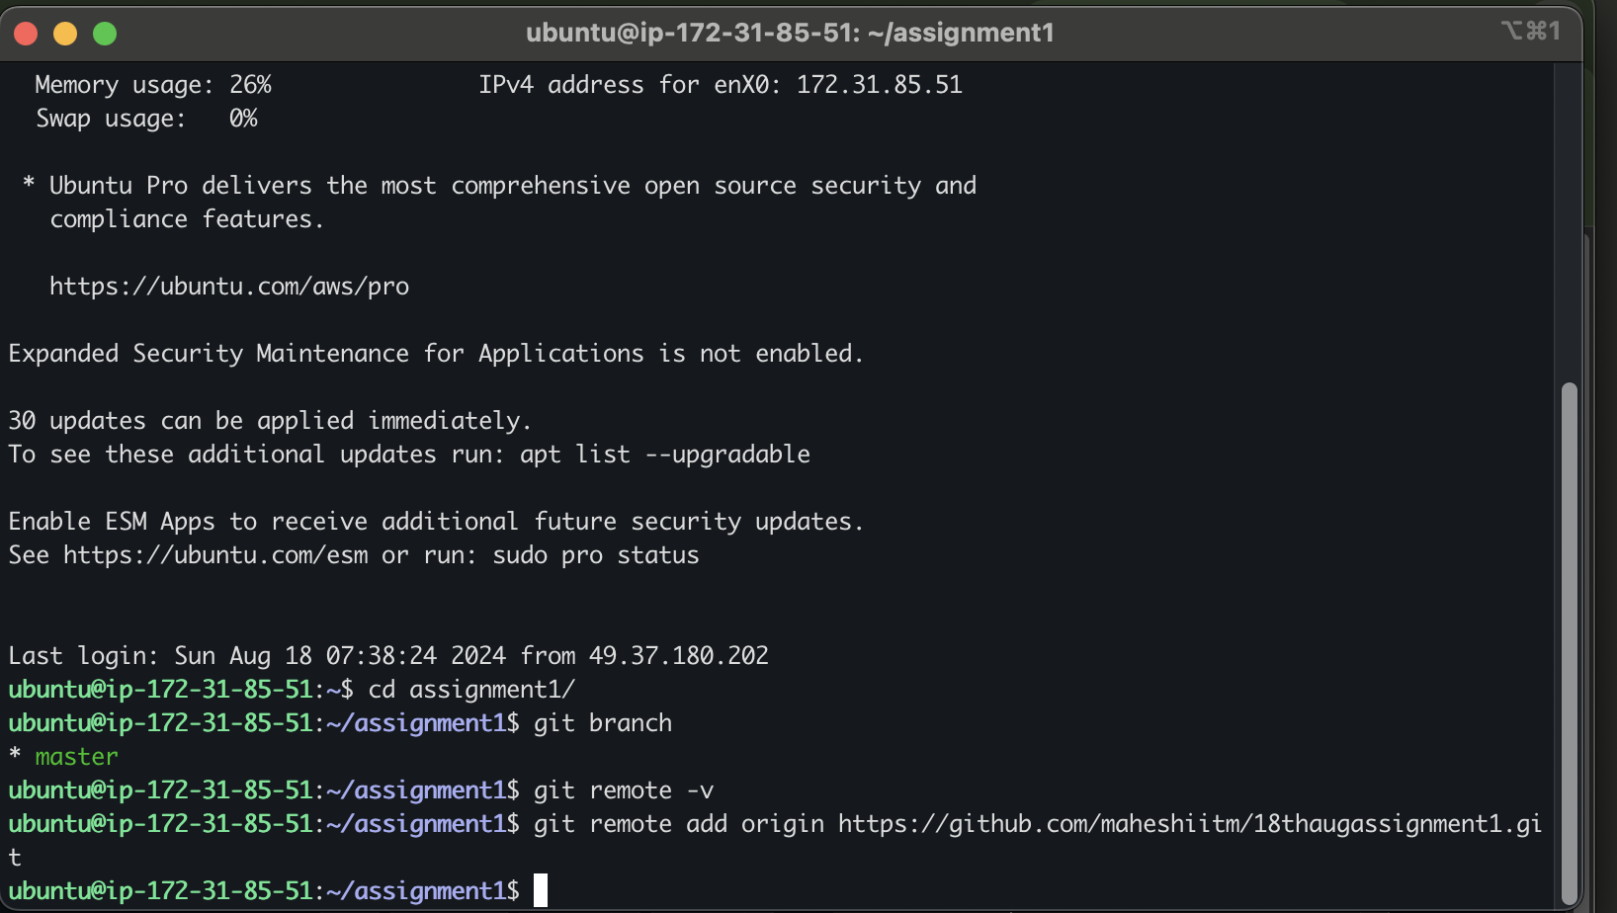

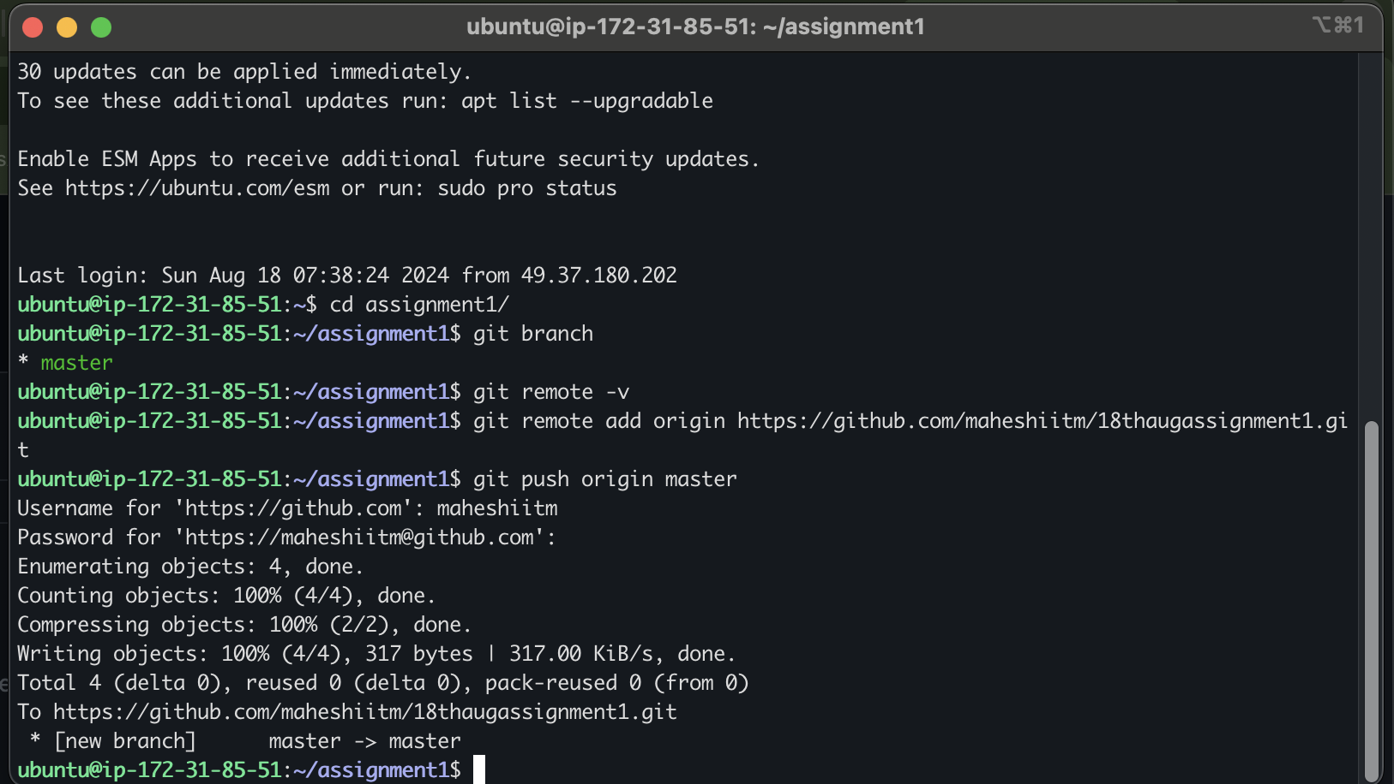

Master branch is successfully pushed .

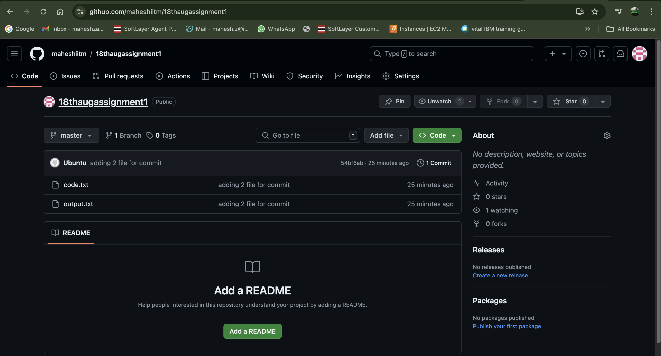

Commands

225 sudo su -

226 ls

227 mkdir assignment1

228 cd assignment1/

229 nano code.txt

230 nano log.txt

231 nano output.txt

232 ls -a

233 git init

234 ls -a

235 cd assignment1/

236 git branch

237 git remote -v

238 git remote add origin https://github.com/maheshiitm/18thaugassignment1.git

239 git push origin master

240 history

Assignment is completed

Thanks